
CSA16 – DATA WAREHOUSING AND DATA MINING

ASSIGNMENT 2 – CO2
Data Mining Functionalities, Data Dispersion and Data Preprocessing: Diagnose, Redesign and Validate
CO2: Analyse data dispersion techniques and list the various algorithms available for mining the data.

Field | Details | Field | Details
Student Name | AJITHA ANGELEN R | Register Number | 192521091
Department / Section | B.TECH IT | Academic Year / Semester | 2026
Faculty Name | Dr. K.V.KANIMOZHI | Nature of Assignment | Individual
Duration | 1 Week | Total Marks | 50
Submission Date |  | Evaluation Date

MARK SHEET (Rubric-based evaluation)
Task | Title | Max | Awarded | Evidence / evaluation focus
1 | Match Business Problems to Mining Functionalities | 5 |  | Functionality; supervised/unsupervised; data and algorithms; single-algorithm evaluation
2 | KDD Process, Architecture and Issues | 5 |  | KDD mapping; architecture diagram; system classification; issue–mitigation
3 | Describe and Compare Data Dispersion | 7 |  | Mean/median/mode; quartiles, IQR, boxplot; outliers; recommendation
4 | Clean Noisy and Incomplete Data | 6 |  | Defect classification; strategy table; binning; imputation impact
5 | Integrate and Transform Data | 7 |  | Conflict resolution; correlation and χ²; normalisation; distance comparison
6 | Data Reduction and Discretization | 7 |  | Reduction strategy; sampling; equal-width/frequency; information gain
7 | Day-4 Design Challenge – Diagnose, Redesign and Validate | 13 |  | Diagnosis; objectives; pipeline; prediction; validation; defence
 | TOTAL | 50 |  | Percentage :

EVIDENCE VERIFICATION CHECKLIST

Tasks | Evidence expected | Status (✓ / P / ✗) | Evaluator note
1 | A table of six problems mapped to functionality, learning type, data and algorithms, with reasoned evaluation of the single-algorithm proposal
2 | KDD mapping, architecture diagram, system classification, issue–mitigation table and reasoned answer
3 | Manual calculations, boxplot, outlier identification, measure classification, tool verification and recommendation
4 | Defect classification, strategy table, binning calculations and discussion on impact of imputation
5 | Conflict-resolution table, correlation and χ² calculations, three normalisation methods and distance comparison
6 | Reduction justification, sampling comparison, equal-width/equal-frequency intervals, information-gain table
7 | Diagnosis, measurable objectives, justified pipeline, written prediction, validated results and defence

IMPLEMENTATION EVIDENCE CHAIN

Evidence item | Status | Observation
Manual calculations |  | Working shown for Q3–Q6 (primary evidence)
Tool / code |  | Weka, KNIME or Python workflow used in Q7 and for verification
Screenshots |  | Tool outputs with the settings used
Dataset |  | Dataset (or link) used in Q7, e.g. UCI German Credit
Prediction |  | Written prediction recorded before implementation
Validation results |  | Original vs redesigned pipeline on same test data
Reproducibility |  | Steps, settings and parameters allow the results to be repeated

OVERALL REMARKS

_______________  Student Signature | _______________  Faculty Signature | _______________  Program Director
MANDATORY SUBMISSION EVIDENCE CHECK
✓ = Present in documented answer; P = Partly present; ✗ = Missing / not satisfied
Task | Evidence expected | Status | Evaluator note
1 | A table of six problems mapped to functionality, learning type, data and algorithms, with reasoned evaluation of the single-algorithm proposal
2 | KDD mapping, architecture diagram, system classification, issue–mitigation table and reasoned answer
3 | Manual calculations, boxplot, outlier identification, measure classification, tool verification and recommendation
4 | Defect classification, strategy table, binning calculations and discussion on impact of imputation
5 | Conflict-resolution table, correlation and χ² calculations, three normalisation methods and distance comparison
6 | Reduction justification, sampling comparison, equal-width/equal-frequency intervals, information-gain table
7 | Diagnosis, measurable objectives, justified pipeline, written prediction, validated results and defence

IMPLEMENTATION EVIDENCE CHAIN
Evidence item | Status | Observation
Source code / workflow |  | Python script or Weka/KNIME workflow for original and redesigned pipelines
Preprocessing steps |  | Ordered steps; training-only computation of statistics
Screenshots |  | Tool outputs with settings; authenticity verified
Dataset |  | Source and size of dataset documented
Prediction vs result |  | Predictions compared with actual results
Metrics comparison |  | Accuracy, precision, recall and F1-score for both pipelines
Code and report consistency |  | Reported results match the submitted code and outputs

SUBMISSION CHECKLIST (Not Separately Marked)
Requirement | Status
All 7 questions answered | ☐ Yes ☐ Partly ☐ No
KDD steps, architecture and mining issues explained | ☐ Yes ☐ Partly ☐ No
Dispersion measures computed manually (Q3) | ☐ Yes ☐ Partly ☐ No
Cleaning and binning calculations shown (Q4) | ☐ Yes ☐ Partly ☐ No
Integration and transformation calculations included (Q5) | ☐ Yes ☐ Partly ☐ No
Reduction and discretization completed (Q6) | ☐ Yes ☐ Partly ☐ No
Q7 implementation and validation evidence provided | ☐ Yes ☐ Partly ☐ No
Day-4 design challenge completed | ☐ Yes ☐ Partly ☐ No
Screenshots and datasets included | ☐ Yes ☐ Partly ☐ No
Table and figure numbering correct | ☐ Yes ☐ Partly ☐ No
Viva recommended | ☐ Yes ☐ No


DEPARTMENT OF COMPUTER SCIENCE AND ENGINEERING
CSA16 Data Warehousing and Data Mining
ASSIGNMENT
Assignment 2 – CO2
CO2 Coverage: Data mining from a database perspective, data mining functionalities, steps in the data mining process (KDD), architecture and classification of data mining systems, basic data mining tasks and issues, data dispersion, data cleaning, integration, transformation, reduction and discretization.

Course Outcome: CO2 – Analyse data dispersion techniques and list the various algorithms available for mining the data.
Nature: Individual | Duration: 1 Week | Total Marks: 50

Q1 – Matching Business Problems to Mining Functionalities 5 Marks
Problem Context – Telecom Subscriber Analytics
TeleNova is a telecom operator with 8 million subscribers. Its analytics team has received the following six business problems:
- P1: Find which plans and add-on services customers typically purchase together.
- P2: Estimate whether a given customer will leave the network next month.
- P3: Divide subscribers into natural usage segments, without any predefined labels.
- P4: Identify SIM cards whose calling behaviour is very different from all others.
- P5: Summarise the general characteristics of high-value customers and show how they differ from low-value customers.
- P6: Study how monthly data usage of customers has changed over the last 24 months.
Your Challenge
For each problem, identify:
- The data mining functionality involved (concept/class description, association, classification, prediction, clustering, outlier analysis or evolution analysis)
- Whether it is supervised or unsupervised, and the kind of pattern or knowledge produced
- The data attributes required and the data source (database or warehouse)
- At least two candidate algorithms from the syllabus and the reason for choosing them
Design Decision
The marketing manager proposes buying a single “all-purpose mining algorithm” for all six problems. Evaluate this proposal using your analysis.
Evidence Expected
A table of six problems mapped to functionality, learning type, data and algorithms, and a reasoned evaluation of the single-algorithm proposal.
Q2 – The KDD Process, System Architecture and Mining Issues 5 Marks
Problem Context – Hospital Readmission Mining
MediCore, a hospital network, wants to discover factors that cause patients to be readmitted within 30 days. Patient data is spread across admission, laboratory, pharmacy and billing systems.
Your Challenge
- Map each KDD step (selection, preprocessing, transformation, mining, interpretation/evaluation) to specific activities MediCore must perform
- Draw the architecture of a typical data mining system for MediCore (database/warehouse server, knowledge base, mining engine, pattern-evaluation module, user interface) and mark where each requirement is handled
- Classify the system on four views: kinds of data, kinds of knowledge, techniques used and applications
- Identify at least five data mining issues specific to this scenario (methodology, user interaction, efficiency and scalability, diversity of data types, privacy/social) and a mitigation for each
Inquiry
A hospital director says: “We already have SQL and statistics, so we do not need data mining.” Using an example from MediCore, explain how a mining task differs from a database query and from a basic statistical summary.
Evidence Expected
KDD mapping, architecture diagram, system classification, issue–mitigation table and a reasoned answer to the director’s statement.
Q3 – Describing and Comparing Data Dispersion 7 Marks
Problem Context – E-Commerce Delivery Times
An e-commerce company recorded the delivery time (in minutes) of 24 orders from one dark store:
28, 31, 33, 35, 35, 36, 38, 40, 41, 42, 42, 43, 45, 46, 48, 50, 52, 53, 55, 58, 61, 64, 72, 95
Your Challenge
- Compute the mean, median, mode, midrange, and comment on what the relationship between mean and median suggests about the distribution
- Compute the range, quartiles Q1 and Q3, IQR, variance and standard deviation, showing your method (state which quartile convention you use)
- Prepare the five-number summary and draw a boxplot; apply the 1.5 × IQR rule to identify outliers
- Remove the largest value and recompute all measures. Which measures changed the most, and why?
- Classify mean, median, variance, standard deviation and range as distributive, algebraic or holistic measures, and explain what this means when the data is split across many warehouse partitions
- Verify your manual results using a tool (spreadsheet, Python, Weka or KNIME statistics node) and explain any difference
Inquiry
The operations team wants to promise customers a “typical” delivery time. Which measure would you recommend and why? What would you report in addition, and why?
Evidence Expected
Manual calculations, boxplot, outlier identification, measure classification, tool verification and a reasoned recommendation.
Q4 – Cleaning Noisy and Incomplete Data 6 Marks
Problem Context – Smart-Meter Energy Readings
A utility collects hourly readings from household smart meters. A sample extract is shown below:
Meter | Household type | kWh | Voltage (V) | Region
M101 | Apartment | 5 | 230 | North
M102 | Apartment | (missing) | 231 | North
M103 | House | 38 | 229 | north
M104 | House | -14 | 232 | South
M105 | (missing) | 19 | 2300 | South
M106 | Apartment | 11 | 230 | S.

The sorted kWh values of 12 other hourly readings are: 5, 9, 11, 14, 18, 19, 23, 26, 27, 30, 33, 38
Your Challenge
- Identify every defect in the extract and classify it (missing value, noise, inconsistency, invalid value)
- For each defect, propose and justify a handling strategy from: ignore the tuple, fill manually, global constant, attribute mean, class-wise mean, or most probable value (regression/inference)
- Apply equal-frequency binning (depth 4) to the 12 sorted values and smooth by bin means and by bin boundaries, showing all bins
- Explain how regression and clustering could be used to detect or smooth noise, and why a reading such as 2300 V must be treated differently from a reading of 5 kWh
Inquiry
Replacing every missing value with the global mean is quick. Explain how this affects the dispersion of the attribute and the quality of patterns mined later, and when it should be avoided.
Evidence Expected
Defect classification, strategy table, binning calculations and a reasoned discussion on the impact of imputation on dispersion and mining.
Q5 – Integration and Transformation of Data 7 Marks
Problem Context – University Data Consolidation
A university combines its Admissions database (attributes: student_id, name, dob, hostel_status, scholarship) with its Learning Management System (attributes: sid, full_name, attendance_pct, marks, scholarship_flag).
Your Challenge
Part A – Integration
- Identify the entity-identification, naming, unit/format and value conflicts and show how they are resolved in the integrated schema
- Explain why integration often creates redundant attributes, and how correlation analysis helps detect them
Part B – Redundancy analysis
- For attendance % = {60, 70, 75, 80, 85, 90} and marks = {52, 58, 66, 70, 79, 85}, compute the Pearson correlation coefficient and interpret it
- For the observed counts below, compute the χ² statistic (with expected values) and state whether hostel status and scholarship are independent at the 0.05 level (critical value for 1 degree of freedom = 3.84)
 | Scholarship | No scholarship | Total
Hostel | 120 | 180 | 300
Day scholar | 80 | 320 | 400
Total | 200 | 500 | 700

Part C – Transformation
- Annual family income (₹) of five students: 20,000; 35,000; 50,000; 80,000; 150,000. Normalise using min-max (0 to 1), z-score and decimal scaling
- Two students have (age, income) = (19, 35,000) and (21, 80,000). Compute their Euclidean distance before and after min-max normalisation of both attributes (assume age range 17–25 and income range 20,000–150,000) and explain what this reveals for distance-based mining
- Give one example each of aggregation, generalisation and attribute construction for this data
Evidence Expected
Conflict-resolution table, correlation and χ² calculations with interpretation, three normalisation methods and a before/after distance comparison.
Q6 – Data Reduction and Discretization 7 Marks
Problem Context – Industrial Sensor Monitoring
A factory logs 200 sensor attributes from machines, producing 5 million rows per month. Analysts need faster mining without losing the ability to detect machine failure.
Your Challenge
Part A – Choosing reduction strategies
- For each category, describe one technique and when it is suitable for this data: data-cube aggregation, attribute subset selection (forward selection, backward elimination, decision-tree induction), dimensionality reduction (PCA), numerosity reduction (sampling, histograms, clustering) and compression
- Compare simple random sampling without replacement, with replacement, cluster sampling and stratified sampling and state which is appropriate if only 0.5% of the rows are failures
- Explain how many principal components you would keep and the criterion you would use
Part B – Discretization by calculation
Temperature readings: 3, 7, 7, 9, 12, 14, 14, 15, 18, 21, 21, 22, 25, 25, 27, 31, 36, 36, 40, 44
- Discretize into 4 intervals using equal-width and equal-frequency binning. Show the intervals and the number of values in each
- Using the labelled values below, find the best entropy-based split point (candidate split points are midpoints between adjacent values; show the information gain of each candidate):
Value | 10 | 12 | 15 | 18 | 22 | 25 | 28 | 31 | 35 | 40
Class | N | N | N | N | Y | Y | N | Y | Y | Y

- Compare the unsupervised and supervised discretization results and explain which suits a classification task.
Evidence Expected
Reduction strategy justification, sampling comparison, equal-width/equal-frequency intervals, information-gain table and a reasoned comparison.

DAY-4 DESIGN CHALLENGE
Q7 – Diagnose, Redesign and Validate 13 Marks
Problem Context – Loan-Default Pipeline Failure
A retail bank built a model to predict loan default. Its preprocessing pipeline was:
- Missing income values were replaced by the global mean income.
- The attribute occupation (18% missing) was dropped.
- Income (highly right-skewed) was discretized into 5 equal-width intervals.
- All numeric attributes were min-max normalised using the complete dataset, before splitting into training and test sets.
- A random 10% sample of rows was used for training. Only 3% of loans in the data are defaults.
The model reported 97% accuracy on the test set. After deployment, it missed most defaulters and the bank lost money.
A. Diagnose the Computational Bottleneck – 2 Marks
Identify the defects in the pipeline. For each, name the data preprocessing principle violated and explain how it can mislead the model or the evaluation.
B. Define the Design Objective – 2 Marks
State measurable objectives (for example the metric to improve and the acceptable trade-off) and the constraints that the redesigned pipeline must satisfy.
C. Design the Revised Preprocessing Strategy – 4 Marks
Design an ordered pipeline that addresses each defect using appropriate cleaning, integration, transformation, reduction and discretization techniques. For each step, justify the technique chosen over at least one alternative and state whether it is computed on training data only.
D. Predict Before Implementing – 1 Mark
Before running anything, predict how your redesign will change: the dispersion of income, the class distribution in the training data, and accuracy versus recall on defaulters.
E. Implement and Validate the Redesign – 2 Marks
Implement the original and the redesigned pipelines on a suitable dataset (for example UCI German Credit or a similar public credit dataset) using Weka, KNIME or Python. Compare them with the same test data and report suitable metrics.
F. Defend the Final Design – 2 Marks
Compare your predictions with the results. Defend your final pipeline, and state one risk that remains.
Evidence Expected
A diagnosis, measurable objectives, a justified pipeline, a written prediction, validated comparison results and a defence of the final design.

MARK DISTRIBUTION
Question | Assessed Area | Marks
Q1 | Mining Functionalities and Algorithm Mapping | 5
Q2 | KDD Process, Architecture and Issues | 5
Q3 | Data Dispersion | 7
Q4 | Data Cleaning | 6
Q5 | Data Integration and Transformation | 7
Q6 | Data Reduction and Discretization | 7
Q7 | Day-4 Design Challenge – Diagnose, Redesign and Validate | 13
TOTAL |  | 50

Submission Requirements
Submit:
- Your assignment report containing the required evidence for Q1–Q7
- Spreadsheets/code/workflows used for calculations and validation
- Screenshots of tool outputs (Weka/KNIME/Python) with the settings used
- Datasets (or links) used in Q7
Manual calculations are primary evidence. Tool output may be used to verify your work but must not replace the working shown.
Assessment Verification
Students may be asked to explain any part of their:
- Manual calculations and their method
- Choice of preprocessing techniques
- Predictions and results
- Design Challenge
during a brief verification discussion/viva. The student should therefore be able to explain and defend the evidence submitted as their own work.
Overall Assessment Expectation
This assignment does not primarily assess your ability to reproduce textbook definitions or tool outputs.
It assesses your ability to:
Understand → Describe → Clean → Transform → Reduce → Predict → Validate → Defend
Your conclusions and design decisions must be supported by your own reasoning and evidence.

Q1 – Matching Business Problems to Mining Functionalities

1. Problem Context
TeleNews is a telecom operator with 8 million subscribers. The analytics team has identified six business problems related to customer behaviour, service usage, customer retention and data analysis.
The objective is to select the appropriate data mining functionality and algorithm for each business problem.

2. Mapping Business Problems to Data Mining Functionalities
Problem | Data Mining Functionality | Learning Type
P1: Find plans and add-on services purchased together | Association Rule Mining | Unsupervised
P2: Predict whether a customer will leave next month | Classification / Prediction | Supervised
P3: Divide subscribers into natural usage groups | Clustering | Unsupervised
P4: Identify SIM cards with unusual calling behaviour | Outlier Analysis | Unsupervised
P5: Compare characteristics of high-value and low-value customers | Concept / Class Description | Descriptive
P6: Analyse changes in monthly data usage over 24 months | Evolution Analysis | Descriptive

3. Detailed Analysis of Each Problem

P1 – Association Rule Mining
- Identifies plans and add-on services that customers frequently purchase together.
- Learning type: Unsupervised learning.
- Pattern produced: Association rules such as Plan A → Add-on B.
- Required attributes: Plan ID, Add-on ID, Customer ID and Purchase History.
- Data source: Telecom transaction database.
- Algorithm: Apriori Algorithm.
- Reason: It identifies frequently occurring combinations and relationships between purchased services.

P2 – Classification / Prediction
- Predicts whether a customer will leave the telecom network in the next month.
- Learning type: Supervised learning.
- Pattern produced: Customer classified as Churn or Not Churn.
- Required attributes: Customer ID, Call Duration, Recharge History, Complaints, Data Usage and Churn Status.
- Data source: Customer database and historical churn records.
- Algorithm: Decision Tree (J48).
- Reason: It uses previously labelled customer data to predict future customer churn.

P3 – Clustering
- Groups subscribers based on similar usage behaviour without predefined labels.
- Learning type: Unsupervised learning.
- Pattern produced: Groups such as Heavy Users, Medium Users and Light Users.
- Required attributes: Monthly Data Usage, Call Duration, Recharge Amount and SMS Usage.
- Data source: Telecom usage database.
- Algorithm: K-Means.
- Reason: It groups customers based on similarity in their usage patterns.

P4 – Outlier Analysis
- Identifies SIM cards showing unusual calling behaviour compared with normal customers.
- Learning type: Unsupervised learning.
- Pattern produced: Unusual or abnormal calling activities.
- Required attributes: Call Frequency, Call Duration, Call Time and Destination Numbers.
- Data source: Call Detail Records (CDR).
- Algorithm: LOF (Local Outlier Factor).
- Reason: It detects unusual behaviour by comparing each record with its neighbouring records.

P5 – Concept / Class Description
- Summarizes the characteristics of high-value customers and compares them with low-value customers.
- Learning type: Descriptive analysis.
- Pattern produced: Customer profiles and differences between customer groups.
- Required attributes: Customer ID, Recharge Amount, Monthly Spending, Data Usage and Subscription Plan.
- Data source: Customer database and data warehouse.
- Technique: OLAP and statistical summarization.
- Reason: It provides a clear summary of customer characteristics and helps the company understand customer value.

P6 – Evolution Analysis
- Studies how customers' monthly data usage changes over the last 24 months.
- Learning type: Descriptive analysis.
- Pattern produced: Monthly usage trends, increasing or decreasing patterns and seasonal changes.
- Required attributes: Customer ID, Month, Year and Monthly Data Usage.
- Data source: Historical telecom usage data warehouse.
- Algorithm: Time-Series Analysis.
- Reason: It identifies changes and trends in customer data usage over time.

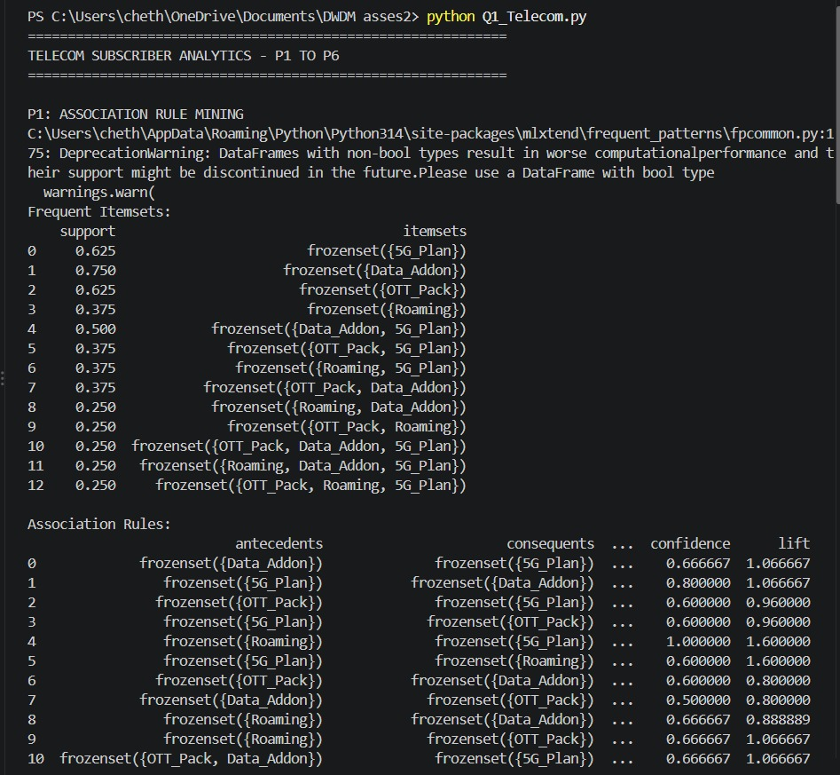
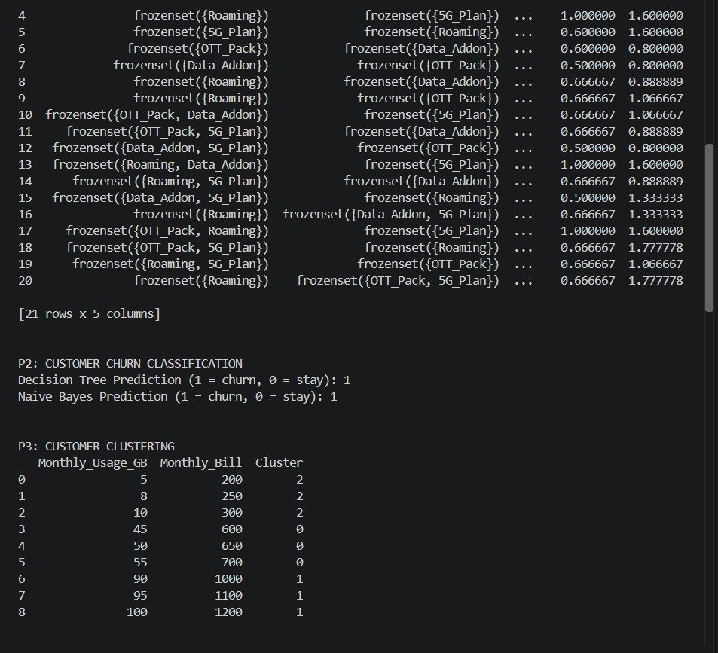
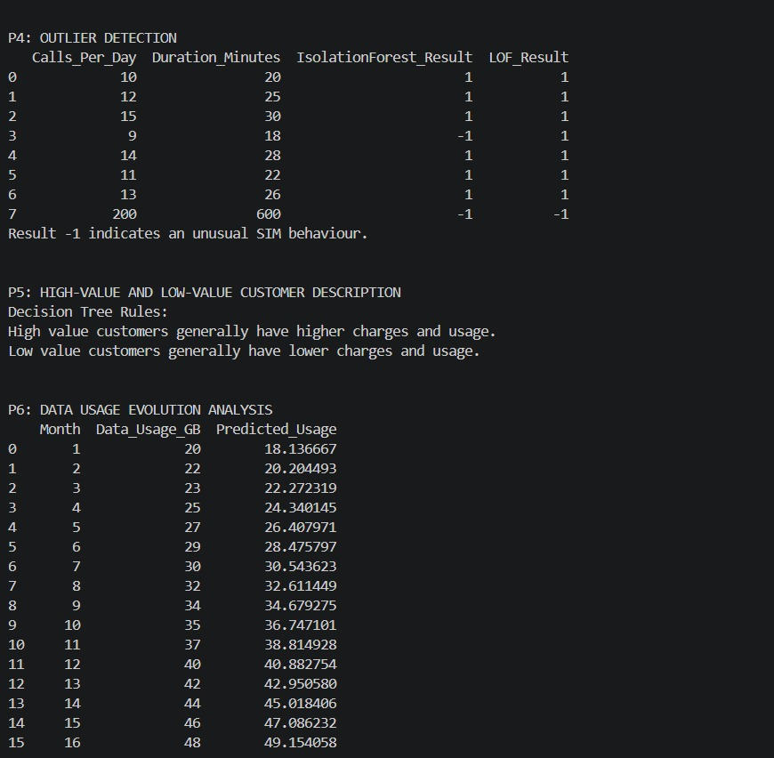
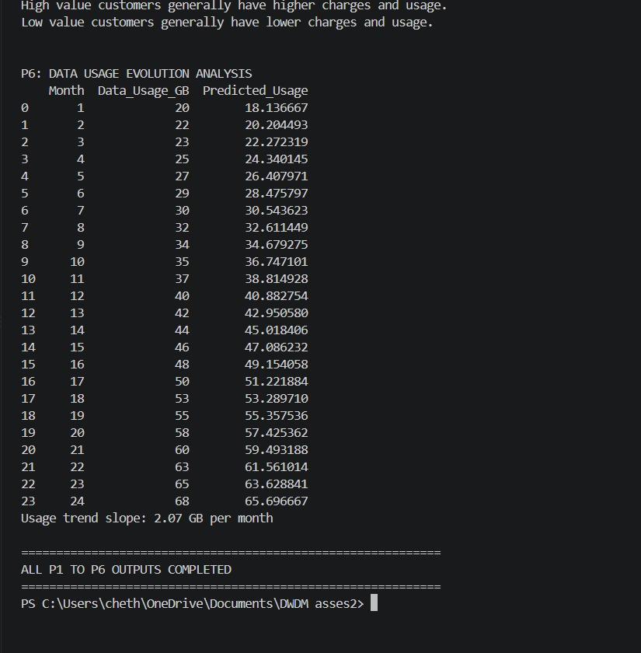
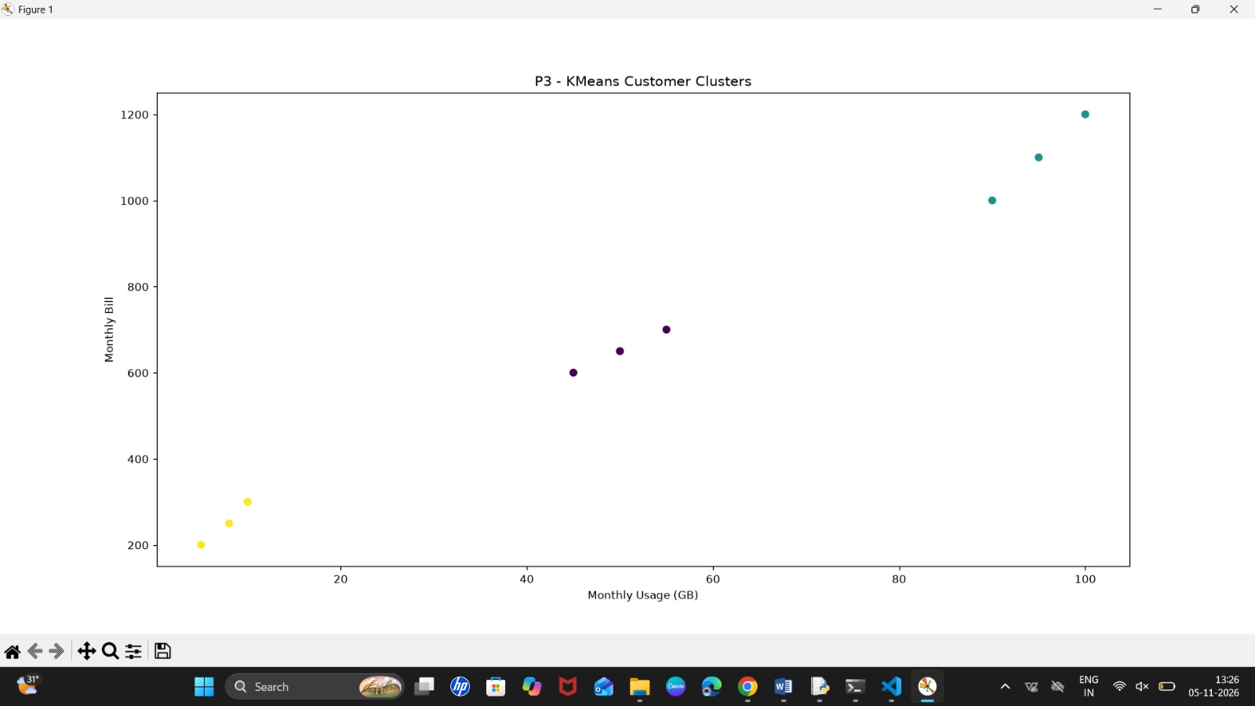
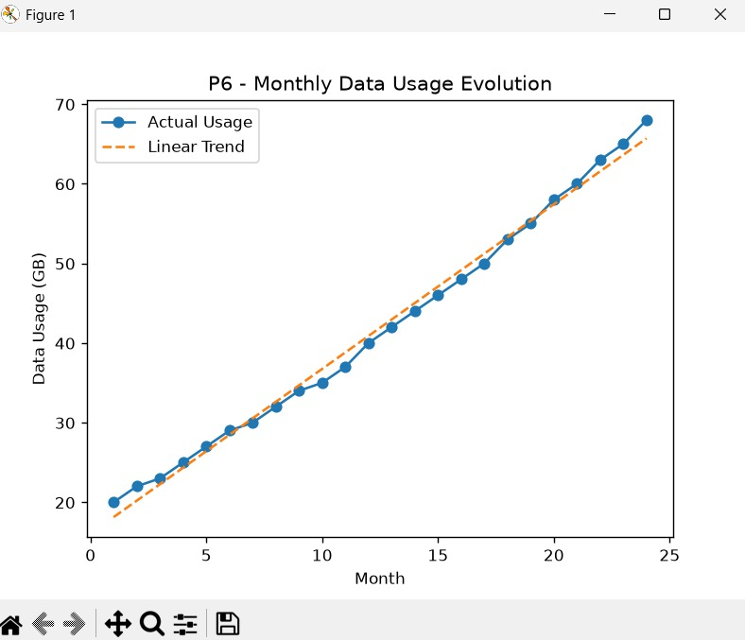

4. Evaluation of the All-Purpose Mining Algorithm Proposal
The marketing manager proposes using a single all-purpose data mining algorithm for all six business problems.
This proposal is not suitable because each problem requires a different mining functionality.
Problem | Suitable Technique
P1 | Association Rule Mining
P2 | Classification
P3 | Clustering
P4 | Outlier Analysis
P5 | Concept Description
P6 | Evolution Analysis
Different algorithms are designed for different purposes. For example, Apriori finds associations, K-Means creates clusters and Decision Trees perform classification.
Therefore, using one algorithm for all six problems may produce inaccurate or meaningless results.

5. Conclusion
Data mining provides different techniques to solve different business problems. By selecting the appropriate functionality and algorithm, TeleNews can understand customer behaviour, predict customer churn, identify unusual activities and improve business decisions. Hence, a problem-specific mining approach is better than using a single all-purpose algorithm.

TASK 2 : HEALTHCARE DATA MINING SYSTEM ARCHITECTURE

1. Introduction
Healthcare organisations generate large amounts of data through admission systems, Electronic Health Records (EHR), laboratory information systems, pharmacy systems and billing applications. Analysing this data manually is difficult because it is collected from different sources and stored in different formats.
A Healthcare Data Mining System helps identify useful patterns, predict patient risks and support clinical decision-making. It uses data integration, data mining algorithms and pattern evaluation techniques to convert raw healthcare data into meaningful information.
The proposed architecture consists of five major components: heterogeneous data sources, database or data warehouse server, data mining engine, pattern evaluation module and user interface. A knowledge base is also connected to the data mining engine and pattern evaluation module to provide medical rules and clinical knowledge.

2. Aim
To design a healthcare data mining system architecture that integrates data from multiple healthcare sources, discovers useful patterns, evaluates their clinical significance and presents actionable insights through a Clinical Decision Support (CDS) dashboard.

3. Description of the Architecture
The architecture illustrates the flow of healthcare information from multiple data sources to the final clinical decision-support interface.

3.1 Heterogeneous Data Sources
The first component collects healthcare information from different hospital systems.
The major sources include:
- Admission systems: Store patient admission, discharge and transfer details.
- Electronic Health Records (EHR): Maintain patient medical history, diagnoses and treatment information.
- Laboratory Information Systems (LIS): Store blood tests, laboratory results and diagnostic reports.
- Pharmacy Information Systems (PIS): Maintain medication prescriptions and dispensing details.
- Billing systems: Store treatment costs, payments and billing information.
These systems provide the raw data required for healthcare analysis.

3.2 Database / Data Warehouse Server
The second component stores, integrates and prepares healthcare data for analysis.
Its major functions are:
- EMPI Entity Resolution: Identifies and matches patient records across different healthcare systems using an Enterprise Master Patient Index.
- ETL Cleaning: Extracts, transforms and loads data while correcting missing, duplicate and inconsistent records.
- Feature Store: Maintains prepared variables or features that are used by machine learning and data mining algorithms.
This stage ensures that data is organised, consistent and suitable for further analysis.

3.3 Data Mining Engine
The third component analyses the prepared healthcare data and discovers useful patterns.
The architecture uses two major techniques:
Readmission Risk Classification: Predicts whether a patient is likely to be readmitted to the hospital within a specified period. It helps healthcare professionals identify high-risk patients and plan appropriate follow-up care.
FP-Growth Rule Mining: Identifies frequently occurring combinations of medical conditions, treatments or other healthcare events. It discovers associations among healthcare records without requiring the generation of candidate itemsets used by Apriori.
The output of this component consists of discovered patterns and predictive results.

3.4 Pattern Evaluation Module
The fourth component evaluates the quality, usefulness and clinical relevance of the patterns discovered by the data mining engine.
Its main functions include:
- Clinical Significance: Checks whether discovered patterns are meaningful and useful in medical practice.
- Utility Checks: Determines whether the patterns can support healthcare decisions.
- AUROC: Measures the ability of a classification model to distinguish between different outcome classes.
- PR-AUC: Evaluates the balance between precision and recall, particularly useful when high-risk readmission cases are relatively uncommon.
Only patterns that meet the required evaluation criteria are passed to the user interface.

3.5 User Interface – Clinical CDS Dashboard
The fifth component presents the evaluated information to doctors and healthcare professionals through a Clinical Decision Support dashboard.
Its main features include:
- Bedside Risk Alerts: Displays alerts for patients identified as having a high risk of readmission.
- Modifiable Factors: Highlights factors that may be addressed through clinical or care-management interventions.
- SHAP Insights: Explains how different input features contribute to an individual model prediction.
The dashboard helps healthcare professionals understand patient risks and make informed decisions. The system supports clinical judgement rather than replacing doctors.

4. Role of the Knowledge Base
The Knowledge Base provides medical knowledge and domain-specific rules to the data mining system.
It contains:
ICD-10 and RxNorm Ontologies: ICD-10 provides standard codes for diseases and health conditions, while RxNorm provides standardised names and information for clinical drugs.
Drug Interaction Rules: Stores information about possible interactions between medicines and helps identify potentially unsafe medication combinations.
Comorbidity Indices: Provides measures of the presence and severity of multiple medical conditions in a patient.
The knowledge base communicates with the data mining engine through domain constraints and mining feedback. It also supports clinical validation in the pattern evaluation module.
This integration ensures that the discovered patterns are evaluated using relevant healthcare knowledge.

5. Working Principle of the Architecture
The healthcare data mining system operates through the following sequence:
- Data is collected from admission systems, EHR, laboratory, pharmacy and billing applications.
- The collected data is transferred to the database or data warehouse server.
- Patient records are matched, cleaned, integrated and transformed into suitable features.
- The prepared dataset is supplied to the data mining engine.
- Readmission risk classification and FP-Growth algorithms are applied to discover useful patterns.
- The knowledge base provides medical rules and domain constraints to guide the mining process.
- The discovered patterns are evaluated for clinical significance and model performance.
- Validated results are displayed through the Clinical CDS dashboard.
- Healthcare professionals use the displayed insights to support patient monitoring and care planning.

6. Data Flow Explanation
The architecture follows a structured data-processing flow.
Stage | Component | Main Function
1 | Heterogeneous Data Sources | Collects patient and hospital data
2 | Database / Data Warehouse | Integrates, cleans and prepares data
3 | Data Mining Engine | Discovers patterns and predicts readmission risk
4 | Pattern Evaluation Module | Evaluates model performance and clinical usefulness
5 | Clinical CDS Dashboard | Displays alerts and useful insights
Supporting | Knowledge Base | Provides medical rules and domain knowledge

7. Technologies and Techniques Used
Technology / Technique | Purpose
EHR | Stores electronic patient health records
LIS | Manages laboratory information
ETL | Cleans and integrates healthcare data
Data Warehouse | Stores integrated healthcare information
Readmission Classification | Predicts patient readmission risk
FP-Growth | Discovers frequent patterns and associations
AUROC | Evaluates classification performance
PR-AUC | Evaluates precision-recall performance
SHAP | Explains model predictions
Clinical CDS | Supports clinical decision-making

8. Advantages of the Proposed Architecture
- Data Integration: Combines healthcare information from different hospital systems into a unified structure.
- Improved Prediction: Identifies patients who may have a higher risk of hospital readmission.
- Pattern Discovery: Finds useful associations among diseases, treatments and healthcare events.
- Better Clinical Support: Provides risk alerts and insights to healthcare professionals.
- Data Quality: ETL cleaning and patient record matching help improve the consistency of information.
- Explainability: SHAP insights help users understand the factors influencing model predictions.
- Clinical Validation: The knowledge base supports the evaluation of discovered patterns using medical rules.

9. Applications
The proposed healthcare data mining architecture can be used in:
- Hospital readmission prediction.
- Patient risk assessment.
- Clinical decision support.
- Disease pattern identification.
- Medication and drug interaction analysis.
- Hospital resource planning.
- Patient monitoring and follow-up management.

10. Limitations and Considerations
The effectiveness of the architecture depends on the quality, completeness and accuracy of healthcare data. Inconsistent patient records may affect analysis and predictions.
Patient privacy and data security must be maintained while integrating information from different systems. Access should be restricted to authorised healthcare professionals.
The prediction results must be clinically validated before being used in patient care. Data mining outputs should support, not replace, professional medical judgement.

11. Result
The healthcare data mining system architecture was designed successfully using PlantUML. The diagram represents the integration of multiple healthcare data sources, data preparation, pattern discovery, clinical evaluation and presentation of results through a Clinical Decision Support dashboard.
The knowledge base provides domain-specific medical rules and supports the validation of discovered patterns.
@startuml
skinparam roundcorner 10
skinparam defaultTextAlignment center
skinparam shadowing false

skinparam rectangle {
BackgroundColor #F8FAFC
BorderColor #475569
FontSize 12
}

rectangle "1. Heterogeneous Data Sources\n(Admission / EHR, Laboratory LIS, Pharmacy PIS, Billing)" as S1 #EBF3FA;line:4682B4
rectangle "2. Database / Data Warehouse Server\n(EMPI Entity Resolution, ETL Cleaning, Feature Store)" as S2 #EBF3FA;line:4682B4
rectangle "3. Data Mining Engine\n(Readmission Risk Classification, FP-Growth Rule Mining)" as S3 #EFF6FF;line:2563EB;line.bold
rectangle "4. Pattern Evaluation Module\n(Clinical Significance & Utility Checks, AUROC/PR-AUC)" as S4 #EBF3FA;line:4682B4
rectangle "5. User Interface (Clinical CDS Dashboard)\n(Bedside Risk Alerts, Modifiable Factors, SHAP Insights)" as S5 #DCFCE7;line:16A34A

rectangle "Knowledge Base\n\n• ICD-10 & RxNorm Ontologies\n• Drug Interaction Rules\n• Comorbidity Indices" as KB #FEF9C3;line:CA8A04

S1 -down-> S2 : Ingests & Harmonizes
S2 -down-> S3 : Cleaned Cohort
S3 -down-> S4 : Discovered Patterns
S4 -down-> S5 : Actionable Rules

S3 <-right-> KB : Domain Constraints / Mining Feedback
KB -down-> S4 : Clinical Validation
@enduml
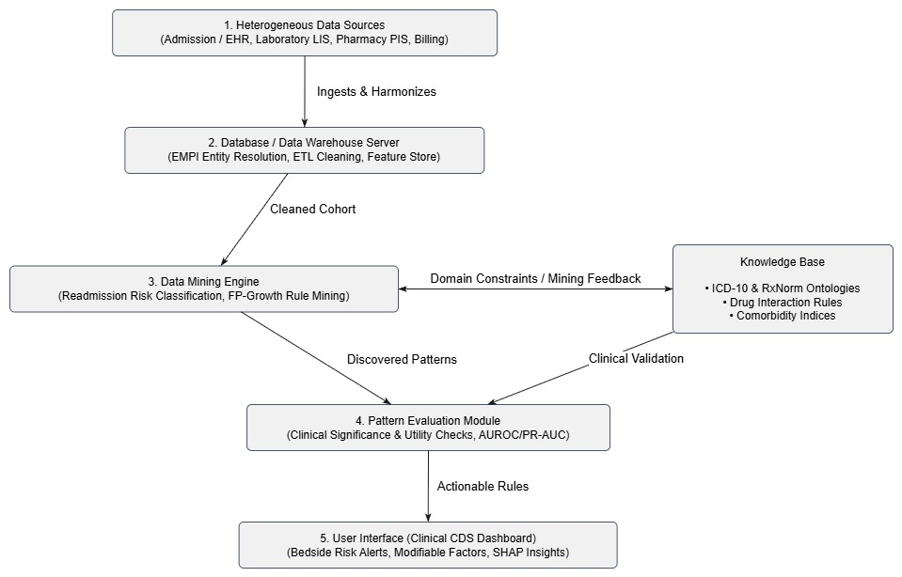

12. Conclusion
The proposed Healthcare Data Mining System provides a structured approach to analysing large volumes of healthcare information. It integrates data from different hospital systems, prepares the data for analysis, applies readmission risk classification and FP-Growth algorithms, and evaluates the discovered patterns using clinical and statistical criteria.
The Clinical CDS dashboard presents useful information through bedside risk alerts, modifiable factors and SHAP explanations. The knowledge base further improves the relevance of the analysis by providing medical ontologies, drug interaction rules and comorbidity information.
Overall, this architecture demonstrates how healthcare data mining can support better clinical decision-making, patient risk assessment and hospital management.

TASK 3: DELIVERY TIME DISPERSION ANALYSIS

1. Introduction
In business operations, delivery time is an important factor that influences customer satisfaction, service quality and overall business performance. Customers generally expect their orders to arrive within a reasonable and predictable period. Delays in delivery can lead to customer complaints, reduced trust and loss of future business.
Statistical analysis helps organisations understand delivery performance by examining the centre, spread and distribution of delivery times. Measures of central tendency explain the typical delivery time, while measures of dispersion show how consistently deliveries are completed.
In this analysis, descriptive statistical techniques are applied to a set of 24 delivery-time observations. The mean, median, mode, midrange, range, quartiles, interquartile range, variance and standard deviation are calculated and interpreted. An outlier is also identified, and the results are compared before and after removing the unusual observation.
The main objectives are:
- To identify the average and typical delivery time.
- To measure the variation in delivery performance.
- To understand the distribution using quartiles and a box-and-whisker plot.
- To identify unusually high or low delivery times.
- To evaluate how an outlier affects statistical results.
- To recommend suitable measures for monitoring delivery performance.

2. Understanding the Delivery-Time Data
The dataset contains 24 observations representing delivery times measured in minutes. Each observation represents the time taken to complete a delivery.
Before performing statistical calculations, the data should be organised and checked for accuracy. This is important because incorrect or missing observations can affect the results and lead to misleading business decisions.
The dataset is analysed using descriptive statistics. These techniques summarise the main characteristics of the data without making predictions about future delivery times.

3. Measures of Central Tendency
Measures of central tendency identify the centre or typical value of a dataset. They help managers understand how long deliveries generally take.

3.1 Mean
The mean is calculated by adding all observations and dividing the total by the number of observations.
Mean = Sum of all observations / Number of observations
The calculated mean delivery time is 47.625 minutes.
This means that the average delivery time across all 24 observations is approximately 47.63 minutes. It provides an overall measure of delivery performance.
However, the mean is sensitive to extreme values. A very high delivery time can increase the average even when most deliveries are completed more quickly.

3.2 Median
The median is the middle value when the observations are arranged in ascending order.
The calculated median is 44 minutes.
This means that approximately half of the delivery observations are at or below 44 minutes, while the other half are at or above 44 minutes.
The median is particularly useful when a dataset contains extreme values because it is not heavily influenced by unusually high or low observations.

3.3 Mode
The mode is the value that occurs most frequently in a dataset.
The dataset has two modes:
- 35 minutes
- 42 minutes
Therefore, the distribution is bimodal. These values represent the most frequently occurring delivery times in the dataset.
The presence of two modes suggests that deliveries commonly occur around two different time values. This may be worth investigating further using additional information about delivery distance, location or operational conditions.

3.4 Midrange
The midrange is the average of the minimum and maximum observations.
Midrange = (Minimum + Maximum) / 2
Calculation:
Midrange = (28 + 95) / 2
Midrange = 61.5 minutes
The midrange represents the centre of the two extreme observations. However, it does not necessarily represent a typical delivery time because it depends only on the minimum and maximum values.

Table 1: Summary of Central Tendency
Measure | Result | Explanation
Mean | 47.625 minutes | Average delivery time
Median | 44 minutes | Middle observation
Mode | 35 and 42 minutes | Most frequent observations
Midrange | 61.5 minutes | Average of minimum and maximum

Interpretation
The mean is higher than the median, which suggests that higher delivery times are pulling the average upward. Therefore, the median provides a more representative measure of typical delivery performance in this dataset.

4. Measures of Dispersion
Measures of dispersion describe how widely the observations are spread around the centre. They help determine whether delivery times are consistent or highly variable.
Two businesses may have the same average delivery time but different levels of consistency. For this reason, dispersion measures are important when evaluating operational performance.
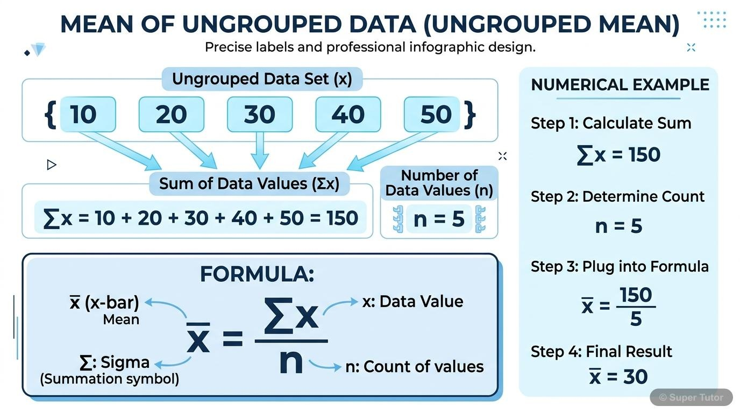

4.1 Minimum and Maximum
The minimum is the smallest delivery time, while the maximum is the largest delivery time.
- Minimum delivery time = 28 minutes.
- Maximum delivery time = 95 minutes.
These values identify the fastest and slowest deliveries in the dataset.
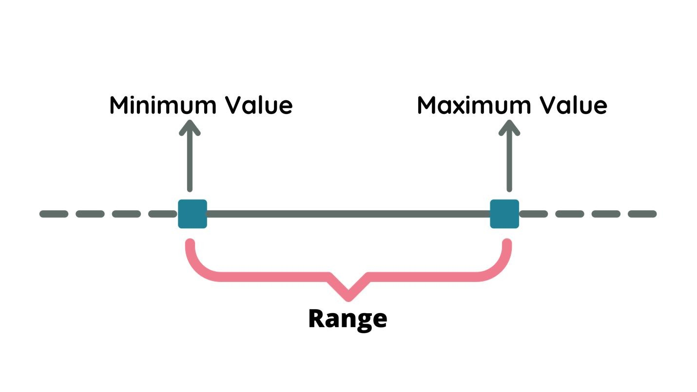

4.2 Range
The range measures the difference between the largest and smallest observations.
Range = Maximum − Minimum
Calculation:
Range = 95 − 28
Range = 67 minutes
The range indicates that the difference between the fastest and slowest deliveries is 67 minutes.
A large range may indicate inconsistent delivery performance. However, the range considers only two observations and can be strongly affected by outliers.

4.3 Quartiles
Quartiles divide an ordered dataset into four sections. They help explain how observations are distributed across the dataset.
- First quartile (Q1): 37 minutes.
- Second quartile (Q2): 44 minutes.
- Third quartile (Q3): 54 minutes.
The first quartile indicates that approximately 25% of observations are at or below 37 minutes. The median divides the data into two equal halves, and the third quartile indicates that approximately 75% of observations are at or below 54 minutes.

4.4 Interquartile Range
The interquartile range measures the spread of the middle 50% of observations.
IQR = Q3 − Q1
Calculation:
IQR = 54 − 37
IQR = 17 minutes
The IQR indicates that the middle half of delivery times is spread across 17 minutes.
Unlike the range, the IQR is less affected by extreme observations. Therefore, it is a useful measure for understanding the variation in normal delivery performance.

Table 2: Measures of Dispersion
Measure | Result | Interpretation
Minimum | 28 minutes | Fastest delivery
Maximum | 95 minutes | Slowest delivery
Range | 67 minutes | Overall spread
Q1 | 37 minutes | First quartile
Q2 | 44 minutes | Median
Q3 | 54 minutes | Third quartile
IQR | 17 minutes | Spread of the middle 50%

5. Quartile Calculation and Interpretation
Quartiles are useful for understanding the relative position of observations in an ordered dataset. They divide the data into four approximately equal groups.

Third Quartile Calculation
For this dataset, the third quartile is calculated by averaging the sixth and seventh values in the upper half.
Q3 = (6th value + 7th value) / 2
Q3 = (53 + 55) / 2
Q3 = 54 minutes
This indicates that approximately 75% of the delivery observations are at or below 54 minutes.
Quartile analysis is useful for businesses because it shows whether most deliveries are completed within an acceptable time and whether a smaller group of deliveries experiences longer delays.

6. Variance and Standard Deviation
Variance and standard deviation are important statistical measures used to understand the amount of variation in a dataset.

6.1 Variance
Variance measures the average squared difference between each observation and the mean.
The population variance for the delivery-time dataset is:
Population variance = 213.318 minutes²
A higher variance indicates that delivery times are more spread out around the mean. A lower variance indicates that observations are closer to the average.
Variance is expressed in squared units, so it is less straightforward to interpret directly in terms of minutes.

6.2 Standard Deviation
Standard deviation is the positive square root of variance. It expresses variation in the original measurement unit.
Population standard deviation = 14.605 minutes
This means that the delivery times show a considerable amount of variation around the average delivery time.
A lower standard deviation would indicate more consistent delivery performance, while a higher standard deviation would indicate less predictable delivery times.

Table 3: Variance and Standard Deviation
Measure | Result | Unit
Mean | 47.625 | Minutes
Population variance | 213.318 | Minutes²
Population standard deviation | 14.605 | Minutes

Interpretation
The standard deviation indicates that delivery times are not identical and vary from one observation to another. Management should therefore examine the causes of delivery delays and identify opportunities to improve consistency.

7. Five-Number Summary and Box-and-Whisker Plot
A five-number summary is a compact method of describing a dataset. It includes the minimum, first quartile, median, third quartile and maximum.

Table 4: Five-Number Summary
Statistical measure | Value
Minimum | 28 minutes
First quartile (Q1) | 37 minutes
Median (Q2) | 44 minutes
Third quartile (Q3) | 54 minutes
Maximum | 95 minutes
A box-and-whisker plot provides a visual representation of these five values. The box represents the middle 50% of the observations, and the line inside the box represents the median. The whiskers show the spread of the non-outlier observations, while separate points may represent outliers.
The plot helps identify the centre, spread and possible skewness of the delivery-time distribution.
Insert the delivery-time box-and-whisker plot here.

Interpretation of the Box Plot
The median is positioned at 44 minutes, while the middle 50% of observations lies between 37 and 54 minutes. This indicates that many delivery times are concentrated within this interval.
The unusually high value of 95 minutes lies beyond the upper outlier limit. It indicates that at least one delivery took substantially longer than the typical delivery time.
The box plot makes it easier to communicate the distribution to managers because it presents the main statistical characteristics in a single visual.

8. Outlier Detection
An outlier is an observation that is unusually far away from the other values in a dataset.
Outliers can occur because of exceptional circumstances, measurement errors or unusual operating conditions. In delivery operations, possible reasons include traffic congestion, vehicle breakdowns, incorrect addresses or unusually long delivery distances.
The interquartile range method can be used to identify potential outliers.
Lower fence = Q1 − 1.5 × IQR
Upper fence = Q3 + 1.5 × IQR

Calculation
Lower fence = 37 − (1.5 × 17) = 11.5 minutes
Upper fence = 54 + (1.5 × 17) = 79.5 minutes
Any observation below 11.5 minutes or above 79.5 minutes is identified as a potential outlier.
Since the maximum delivery time is 95 minutes, it exceeds the upper fence of 79.5 minutes.
Therefore, 95 minutes is identified as an outlier.
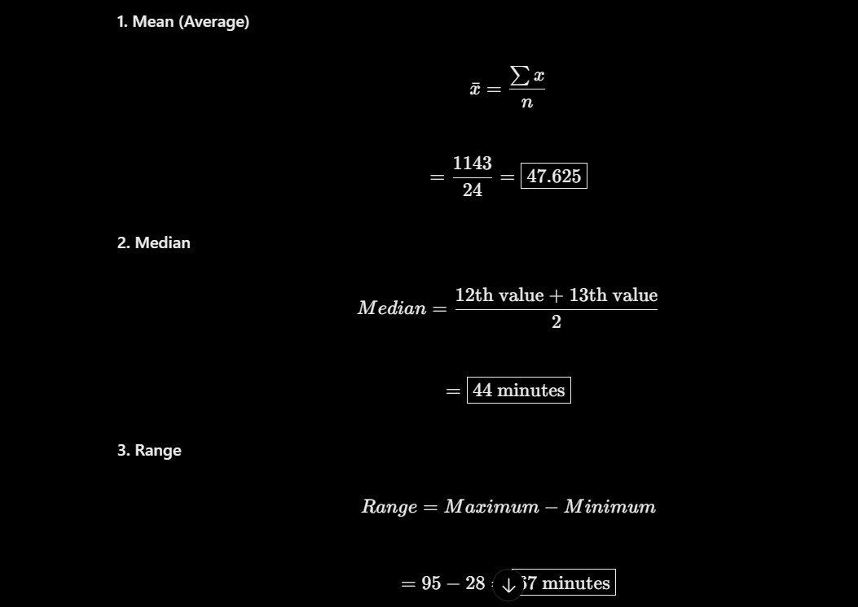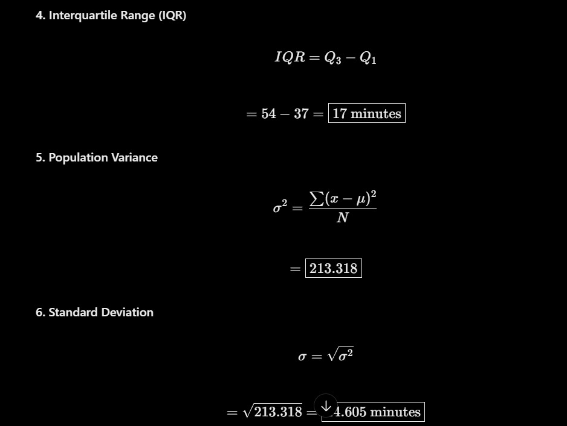

Importance of Outlier Detection
Outlier detection is important because extreme observations can influence several statistical measures. In this dataset, the 95-minute observation increases the mean, range, variance and standard deviation.
However, an outlier should not automatically be deleted. It may represent a genuine delivery problem that management needs to understand. The observation should be investigated before deciding whether to exclude it from a particular analysis.

9. Comparison Before and After Removing the Outlier
To understand the effect of the outlier, the statistical measures are recalculated after removing the 95-minute observation.
This comparison shows how one unusually high delivery time can affect the overall results.

Table 5: Statistical Comparison
Measure | With outlier | Without outlier
Number of observations | 24 | 23
Mean | 47.625 | 45.565
Median | 44 | 43
Mode | 35 and 42 | 35 and 42
Midrange | 61.5 | 50
Range | 67 | 44
Q1 | 37 | 36
Q3 | 54 | 53
IQR | 17 | 17
Population variance | 213.318 | 120.767
Population standard deviation | 14.605 | 10.989

Analysis of the Comparison
The mean decreases from 47.625 minutes to approximately 45.565 minutes after removing the outlier. This shows that the unusually high observation increases the overall average.
The range decreases from 67 minutes to 44 minutes. This demonstrates that the maximum value has a strong effect on the total spread.
The population standard deviation also decreases from 14.605 minutes to approximately 10.989 minutes. This means that the remaining observations are less dispersed around their mean.
The median changes only slightly, from 44 minutes to 43 minutes. This confirms that the median is more resistant to extreme values than the mean.
The IQR remains 17 minutes, showing that the spread of the middle 50% is unchanged in this comparison.
Overall, the comparison demonstrates why both central tendency and dispersion measures should be considered when analysing operational data.

10. Classification of Statistical Measures
Statistical measures can be classified according to how they can be calculated from data summaries.

Algebraic Measures
Algebraic measures can be calculated using a fixed number of summary values. Examples include the mean, variance and standard deviation.
These measures are useful when large datasets need to be summarised efficiently.

Holistic Measures
Holistic measures generally require more detailed information about the observations and cannot always be calculated accurately from a small fixed set of summary values.
The median is an example because the data must be ordered to identify the middle position.

Distributive Measures
Distributive measures can be calculated by combining corresponding results from separate groups or partitions. Examples include minimum, maximum, count and sum.

Table 6: Classification
Measure | Classification
Mean | Algebraic
Median | Holistic
Variance | Algebraic
Standard deviation | Algebraic
Minimum | Distributive
Maximum | Distributive
Count | Distributive
Sum | Distributive
These classifications are useful in data analytics because they help determine which measures can be efficiently calculated when data is divided into smaller groups.

11. Business Implications
The results of this analysis provide useful information for delivery management.
Customer satisfaction: Delivery time is an important part of the customer experience. Consistent delivery performance can improve customer confidence and satisfaction.
Operational efficiency: The variation in delivery times indicates that the organisation may need to examine its delivery routes, staff allocation and scheduling procedures.
Delay investigation: The 95-minute outlier should be investigated to understand why the delivery took significantly longer than the typical delivery time.
Performance monitoring: Regular monitoring of the median, IQR and standard deviation can help management identify changes in delivery performance over time.
Resource planning: Understanding the distribution of delivery times can help managers plan staff availability and delivery capacity more effectively.
import numpy as np
from statistics import multimode

data = [28,31,33,35,35,36,38,40,41,42,
42,43,45,46,48,50,52,53,55,58,
61,64,72,95]

def calculate(data):
print("Mean:", np.mean(data))
print("Median:", np.median(data))
print("Mode:", multimode(data))
print("Midrange:", (min(data)+max(data))/2)
print("Range:", max(data)-min(data))

print("Q1:", np.median(data[:len(data)//2]))

n = len(data)
if n % 2 == 0:
upper = data[n//2:]
else:
upper = data[n//2+1:]

print("Q3:", np.median(upper))
print("Variance:", np.var(data))
print("Standard Deviation:", np.std(data))

print("Original Data")
calculate(data)

print("\nAfter Removing 95")
calculate(data[:-1])
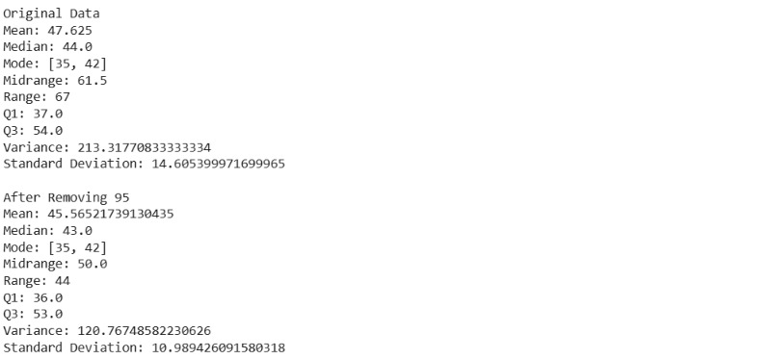

12. Recommendations
Based on the statistical findings, the following recommendations are suggested:
- Use the median as the main typical delivery-time measure. The median of 44 minutes is less affected by extreme values than the mean.
- Monitor delivery-time variation. The IQR of 17 minutes provides information about the spread of the middle 50% of delivery observations.
- Investigate unusually delayed deliveries. The 95-minute observation should be examined to identify its possible cause.
- Improve delivery scheduling. Delivery routes and time estimates should be reviewed to reduce unnecessary delays.
- Monitor performance regularly. Management should calculate delivery-time statistics periodically to identify changes in operational performance.
- Use additional performance indicators. The organisation can also monitor the percentage of deliveries completed within a promised time, customer complaints and average delay duration.
- Avoid deleting genuine unusual observations without investigation. Outliers may reveal important operational problems and should be retained when they represent real delivery experiences.

13. Limitations of the Analysis
Although descriptive statistics provide useful information, there are some limitations.
First, the analysis is based on only 24 delivery observations. A larger dataset collected over a longer period may provide a more complete understanding of delivery performance.
Second, the analysis does not include factors such as delivery distance, traffic conditions, weather, location or the number of delivery staff. These factors may influence delivery time.
Third, descriptive statistics describe the available observations but do not independently explain why delays occur.
Finally, the results should be updated regularly because delivery performance may change due to seasonal demand, operational improvements or changes in customer locations.

14. Conclusion
The statistical analysis provides a detailed understanding of delivery-time performance. The mean delivery time is 47.625 minutes, while the median is 44 minutes. The dataset has two modes, 35 and 42 minutes, and a midrange of 61.5 minutes.
The range is 67 minutes, while the interquartile range is 17 minutes. The population variance is 213.318 minutes², and the population standard deviation is 14.605 minutes.
The outlier analysis identifies 95 minutes as an unusually high delivery time because it exceeds the upper fence of 79.5 minutes. Removing this observation reduces the mean and standard deviation, demonstrating its influence on the overall variation.
The analysis suggests that the median and interquartile range are useful measures for describing typical delivery performance. At the same time, investigating unusual delivery times can help management identify operational problems and improve service quality.
In conclusion, the use of descriptive statistics helps organisations understand delivery performance, make informed decisions and develop strategies to improve delivery consistency and customer satisfaction.

TASK 4 – Cleaning Noisy and Incomplete Data (6 Marks)

1. Identification of Data Defects
Data cleaning is the process of identifying and correcting missing, noisy, inconsistent and invalid data.
The given smart-meter dataset contains the following defects:
Meter | Defect | Type of Defect | Suggested Handling
M102 | Missing kWh value | Missing value | Replace using attribute mean or most probable value
M103 | Region entered as north | Inconsistency | Standardize as North
M104 | kWh value is -14 | Invalid value | Verify and correct manually; otherwise treat as missing
M105 | Household type missing | Missing value | Replace using most probable value
M105 | Voltage is 2300 V | Invalid / noisy value | Verify and correct to 230 V if confirmed
M106 | Region entered as S. | Inconsistency | Standardize as South

2. Handling Strategies
The following methods can be used to handle data defects:
1. Ignore the Tuple: Remove a record if it contains too many errors and cannot be corrected reliably.
2. Fill Manually: Correct values using the original source or meter records.
3. Global Constant: Replace missing values with a constant such as Unknown.
4. Attribute Mean: Replace missing numerical values using the mean of that attribute.
5. Class-wise Mean: Replace missing numerical values using the mean of the same class or group.
6. Most Probable Value: Predict missing values using regression, classification or other inference methods.
For this dataset, manual verification is suitable for invalid readings such as -14 kWh and 2300 V. Missing household type can be replaced using the most probable value.

3. Equal-Frequency Binning (Depth 4)
Given sorted kWh readings:
5, 9, 11, 14, 18, 19, 23, 26, 27, 30, 33, 38
Equal-frequency binning divides the data into bins containing an equal number of values.
Number of readings = 12
Number of bins = 4
Bin depth = 12 / 4 = 3 values per bin.
Bin Formation
Bin | Values
Bin 1 | 5, 9, 11
Bin 2 | 14, 18, 19
Bin 3 | 23, 26, 27
Bin 4 | 30, 33, 38

4. Smoothing by Bin Means
In this method, every value in a bin is replaced by the mean of that bin.
Formula:
Bin Mean = Sum of values / Number of values
Bin 1:
Mean = (5 + 9 + 11) / 3 = 8.33
Smoothed values = 8.33, 8.33, 8.33
Bin 2:
Mean = (14 + 18 + 19) / 3 = 17
Smoothed values = 17, 17, 17
Bin 3:
Mean = (23 + 26 + 27) / 3 = 25.33
Smoothed values = 25.33, 25.33, 25.33
Bin 4:
Mean = (30 + 33 + 38) / 3 = 33.67
Smoothed values = 33.67, 33.67, 33.67
Final Result – Smoothing by Bin Means
Bin | Original Values | Smoothed Values
Bin 1 | 5, 9, 11 | 8.33, 8.33, 8.33
Bin 2 | 14, 18, 19 | 17, 17, 17
Bin 3 | 23, 26, 27 | 25.33, 25.33, 25.33
Bin 4 | 30, 33, 38 | 33.67, 33.67, 33.67

5. Smoothing by Bin Boundaries
In this method, each value is replaced by the nearest boundary value in its bin.
Bin | Original Values | Bin Boundaries | Smoothed Values
Bin 1 | 5, 9, 11 | 5 and 11 | 5, 11, 11
Bin 2 | 14, 18, 19 | 14 and 19 | 14, 19, 19
Bin 3 | 23, 26, 27 | 23 and 27 | 23, 27, 27
Bin 4 | 30, 33, 38 | 30 and 38 | 30, 30, 38

6. Role of Regression and Clustering in Noise Detection
Regression:
Regression is used to estimate missing or incorrect numerical values based on the relationship between attributes. For example, voltage readings can be predicted using previous readings and other sensor information.
Clustering:
Clustering groups similar data values together. Values that are far away from their cluster may be identified as outliers or noisy readings.
Difference between 2300 V and 5 kWh:
A voltage reading of 2300 V is likely an invalid measurement or data-entry error because normal voltage readings in the given records are around 230 V. It must be verified before correction.
A reading of 5 kWh is a valid energy reading. It should not be removed simply because it is lower than other readings.

7. Effect of Replacing Missing Values with Global Mean
Replacing every missing value with the global mean reduces the dispersion of the dataset because many missing values become equal to the same average value.
It reduces variation and may hide important differences between households. This can affect clustering, classification and pattern mining results.
Global mean replacement should be avoided when the data contains different groups or when the missing values are related to other attributes. In such cases, class-wise mean or prediction methods may provide better results.

Conclusion
Data cleaning improves the quality and reliability of smart-meter readings. Missing values, noisy readings, invalid values and inconsistencies must be handled carefully. Equal-frequency binning with bin means and bin boundaries helps smooth small fluctuations. Regression and clustering can also help detect unusual readings and improve the quality of data mining.

TASK 5 – INTEGRATION AND TRANSFORMATION OF DATA
Problem Context – University Data Consolidation

1. INTRODUCTION
Data integration and data transformation are important steps in the data preprocessing process. In real-world applications, data is collected from different sources and stored in separate databases. The data may contain duplicate records, missing values, different formats and inconsistent attribute names.
A university maintains student information in two different systems:
- Admissions Database
- Learning Management System (LMS)
The Admissions Database stores personal and admission details, while the LMS stores academic information such as attendance and marks. Combining these databases helps the university maintain complete student information in one place.
Data integration combines information from multiple sources, while data transformation converts the data into a suitable format for analysis and data mining.

2. OBJECTIVES
The main objectives of this task are:
- To understand the process of data integration.
- To identify matching entities and attributes from different databases.
- To detect duplicate, missing and inconsistent information.
- To study redundancy using Pearson correlation and Chi-Square analysis.
- To apply different data normalization techniques.
- To calculate Euclidean distance before and after normalization.
- To understand the importance of data preprocessing in data mining.

PART A – INTEGRATION

3. DATA INTEGRATION
Data integration is the process of combining data from multiple sources into a single unified database. It helps to provide consistent and complete information for analysis.
In this university system, student details are collected from the Admissions Database and Learning Management System.

3.1 Admissions Database
The Admissions Database contains personal and admission-related information.
The attributes are:
- Student ID
- Name
- Date of Birth (DOB)
- Postal Status
- Scholarship

3.2 Learning Management System (LMS)
The LMS Database contains academic information about students.
The attributes are:
- Student ID
- Full Name
- Attendance
- Marks
- Scholarship Flag

3.3 Identification of Matching Entities
Matching entities are attributes that represent the same information in different databases.
Admissions Database | LMS Database | Common Attribute
Student ID | Student ID | Student ID
Name | Full Name | Student Name
Scholarship | Scholarship Flag | Scholarship Status
Student ID is selected as the common key because it uniquely identifies each student.

3.4 Identification of Data Conflicts
During data integration, different types of conflicts may occur.
Conflict | Description | Solution
Naming conflict | Name and Full Name represent the same information | Use a common name
Format conflict | Dates may have different formats | Convert to YYYY-MM-DD
Value conflict | Scholarship may be stored as Yes/No or Y/N | Use a common format
Entity conflict | The same student may appear in both databases | Match using Student ID
Missing data | Some student details may be unavailable | Use suitable missing-value handling
Duplicate data | The same information may appear more than once | Remove duplicate records

3.5 Identification of Redundant Attributes
Redundant attributes are attributes that contain duplicate or repeated information.
Examples:
- Name and Full Name may contain the same student name.
- Scholarship and Scholarship Flag may represent the same scholarship information.
- Student ID may be repeated in both databases as a linking key.
Redundant attributes should be identified before integration to avoid unnecessary duplication.

3.6 Steps Involved in Data Integration
Step 1 – Data Collection: Collect student information from the Admissions Database and LMS.
Step 2 – Schema Matching: Identify common attributes such as Student ID and Student Name.
Step 3 – Entity Identification: Match records belonging to the same student.
Step 4 – Conflict Detection: Identify different formats, missing values and inconsistent information.
Step 5 – Redundancy Removal: Remove unnecessary duplicate attributes and records.
Step 6 – Data Merging: Combine the information into a single integrated database.
Step 7 – Data Validation: Check the integrated database for accuracy and consistency.

3.7 Integrated Database Structure
The following table represents an example of an integrated student database.
Student ID | Student Name | DOB | Postal Status | Scholarship | Attendance | Marks
101 | Arun | 2005-01-12 | Local | Yes | 85% | 90
102 | Priya | 2005-05-20 | Hostel | No | 78% | 82
103 | Ravi | 2004-11-15 | Local | Yes | 92% | 95
104 | Divya | 2005-08-10 | Hostel | No | 88% | 86
105 | Karthik | 2004-12-25 | Local | Yes | 95% | 93
Note: These are illustrative sample records used to demonstrate the integrated database structure.

3.8 Advantages of Data Integration
- Provides complete student information in one database.
- Reduces duplicate records.
- Improves data consistency.
- Makes data analysis easier.
- Saves time in retrieving student information.
- Supports better academic decision-making.
- Improves the quality of data mining results.

3.9 Challenges in Data Integration
Challenge | Explanation | Solution
Data duplication | Same information appears repeatedly | Duplicate removal
Different formats | Data is stored in different formats | Format standardization
Missing values | Some student details are unavailable | Data cleaning
Inconsistent values | Different values represent the same information | Value standardization
Large data volume | Combining large databases requires more processing | Efficient integration methods
Result of Part A: The Admissions Database and LMS Database are integrated into a unified student database using Student ID as the common key.

PART B – REDUNDANCY ANALYSIS

4. INTRODUCTION TO REDUNDANCY ANALYSIS
Redundancy analysis is used to identify unnecessary or repeated information in a dataset. It helps reduce duplication and improve the quality of data.
Two important statistical techniques used in this task are:
- Pearson Correlation Coefficient.
- Chi-Square Test.
Pearson correlation is used to study the relationship between numerical attributes, while the Chi-Square test is used to study the association between categorical attributes.

4.1 Pearson Correlation Coefficient
Pearson correlation measures the strength and direction of the linear relationship between two numerical variables.
In this university example, attendance percentage and examination marks are considered.
Given Data:
Attendance (X) = 60, 70, 75, 80, 85, 90
Marks (Y) = 52, 58, 66, 70, 79, 85

Formula
r = [nΣXY − ΣXΣY] / √[(nΣX² − (ΣX)²)(nΣY² − (ΣY)²)]
Where:
- r = Pearson correlation coefficient
- n = Number of observations
- X = Attendance percentage
- Y = Examination marks
- ΣXY = Sum of products of X and Y
- ΣX² = Sum of squares of X
- ΣY² = Sum of squares of Y

Calculation Table
X | Y | X² | Y² | XY
60 | 52 | 3600 | 2704 | 3120
70 | 58 | 4900 | 3364 | 4060
75 | 66 | 5625 | 4356 | 4950
80 | 70 | 6400 | 4900 | 5600
85 | 79 | 7225 | 6241 | 6715
90 | 85 | 8100 | 7225 | 7650
Total | 410 | 35850 | 28790 | 32095
ΣX = 460
ΣY = 410
ΣX² = 35850
ΣY² = 28790
ΣXY = 32095
n = 6

Step-by-Step Calculation
Substitute the values into the formula.
r = [6(32095) − (460 × 410)] / √[(6 × 35850 − 460²)(6 × 28790 − 410²)]
r = [192570 − 188600] / √[(215100 − 211600)(172740 − 168100)]
r = 3970 / √(3500 × 4640)
r = 3970 / 4029.89
r = 0.9851

Interpretation of Pearson Correlation
The calculated Pearson correlation coefficient is approximately 0.9851.
This indicates a very strong positive correlation between attendance and examination marks.
It means that students with higher attendance generally tend to achieve higher marks.

Importance of Pearson Correlation
- Identifies relationships between numerical attributes.
- Helps detect highly related variables.
- Supports feature selection.
- Helps identify possible redundant attributes.
- Improves the efficiency of data analysis.

4.2 Chi-Square Test
The Chi-Square test is a statistical method used to identify whether two categorical variables are associated or independent.
In this example, the relationship between hostel status and scholarship availability is analysed.

Given Observed Frequency Table
Student Type | Scholarship | No Scholarship | Total
Hostel | 120 | 180 | 300
Day Scholar | 80 | 320 | 400
Total | 200 | 500 | 700

Hypotheses
Null Hypothesis (H₀): Hostel status and scholarship availability are independent.
Alternative Hypothesis (H₁): Hostel status and scholarship availability are associated.

Formula for Expected Frequency
Expected Frequency = (Row Total × Column Total) / Grand Total

Calculation of Expected Frequencies
1. Hostel – Scholarship
E = (300 × 200) / 700
E = 85.71
2. Hostel – No Scholarship
E = (300 × 500) / 700
E = 214.29
3. Day Scholar – Scholarship
E = (400 × 200) / 700
E = 114.29
4. Day Scholar – No Scholarship
E = (400 × 500) / 700
E = 285.71

Expected Frequency Table
Student Type | Scholarship | No Scholarship
Hostel | 85.71 | 214.29
Day Scholar | 114.29 | 285.71

Chi-Square Formula
χ² = Σ (O − E)² / E
Where:
- O = Observed Frequency
- E = Expected Frequency
- χ² = Chi-Square statistic

Calculation
χ² = (120 − 85.71)² / 85.71
- (180 − 214.29)² / 214.29
- (80 − 114.29)² / 114.29
- (320 − 285.71)² / 285.71
χ² = 13.71 + 5.49 + 10.29 + 4.11
χ² = 33.60

Decision
Degrees of Freedom:
df = (Rows − 1) × (Columns − 1)
df = (2 − 1) × (2 − 1)
df = 1
At the 0.05 significance level, the critical value is 3.84.
Calculated value = 33.60
Critical value = 3.84
Since 33.60 is greater than 3.84, the null hypothesis is rejected.

Interpretation
There is a statistically significant association between hostel status and scholarship availability.
The result indicates that the distribution of scholarship recipients differs between hostel students and day scholars.
However, the test does not establish that hostel status causes scholarship availability.

Importance of Chi-Square Analysis
- Identifies relationships between categorical attributes.
- Helps analyse student groups.
- Supports decision-making.
- Detects possible dependencies between attributes.
- Helps identify unnecessary or related attributes during data preprocessing.

4.3 Comparison Between Pearson Correlation and Chi-Square Test
Feature | Pearson Correlation | Chi-Square Test
Data type | Numerical | Categorical
Purpose | Measures linear relationship | Tests association
Result | Correlation coefficient | Chi-Square statistic
Range | -1 to +1 | 0 or greater
Example | Attendance and marks | Hostel and scholarship
Application | Numerical feature analysis | Categorical feature analysis
Result of Part B: Pearson correlation identifies a strong positive relationship between attendance and marks. The Chi-Square test identifies a significant association between hostel status and scholarship availability.

PART C – TRANSFORMATION

5. INTRODUCTION TO DATA TRANSFORMATION
Data transformation is the process of converting data from one format or scale into another suitable format for data mining.
Different attributes may have different numerical ranges. For example, age may range from 17 to 25, while annual income may range from ₹20,000 to ₹1,50,000.
If these attributes are used directly, the attribute with larger numerical values may dominate distance calculations.
Normalization helps solve this problem by converting values into a common scale.
The three normalization methods used in this task are:
- Min-Max Normalization.
- Z-Score Normalization.
- Decimal Scaling Normalization.

5.1 Min-Max Normalization
Min-Max normalization converts numerical values into a specified range, usually 0 to 1.

Formula
X' = (X − Minimum) / (Maximum − Minimum)
Where:
- X = Original value
- Minimum = Minimum value in the dataset
- Maximum = Maximum value in the dataset
- X' = Normalized value

Given Annual Family Income
₹20,000, ₹35,000, ₹50,000, ₹80,000, ₹1,50,000
Minimum = 20,000
Maximum = 1,50,000
Range = 1,50,000 − 20,000
Range = 1,30,000

Step-by-Step Calculation
For ₹20,000:
X' = (20,000 − 20,000) / 1,30,000
X' = 0
For ₹35,000:
X' = (35,000 − 20,000) / 1,30,000
X' = 0.1154
For ₹50,000:
X' = (50,000 − 20,000) / 1,30,000
X' = 0.2308
For ₹80,000:
X' = (80,000 − 20,000) / 1,30,000
X' = 0.4615
For ₹1,50,000:
X' = (1,50,000 − 20,000) / 1,30,000
X' = 1

Min-Max Normalization Table
Original Income | Normalized Value
20,000 | 0.0000
35,000 | 0.1154
50,000 | 0.2308
80,000 | 0.4615
1,50,000 | 1.0000

Advantages
- Converts data into a fixed range.
- Makes different attributes comparable.
- Helps distance-based algorithms.
- Easy to calculate and understand.
- Preserves the relative order of values.

Disadvantage
Min-Max normalization is sensitive to extreme values because minimum and maximum values determine the normalized range.

5.2 Z-Score Normalization
Z-Score normalization converts data based on the mean and standard deviation.
It shows how far a particular value is from the average value.

Formula
Z = (X − Mean) / Standard Deviation

Given Data
20,000, 35,000, 50,000, 80,000, 1,50,000

Step 1 – Calculate Mean
Mean = Sum of all values / Number of values
Mean = (20,000 + 35,000 + 50,000 + 80,000 + 1,50,000) / 5
Mean = 3,35,000 / 5
Mean = 67,000

Step 2 – Calculate Standard Deviation
For population standard deviation:
σ = √[Σ(X − Mean)² / N]
Income | X − Mean | (X − Mean)²
20,000 | -47,000 | 2,209,000,000
35,000 | -32,000 | 1,024,000,000
50,000 | -17,000 | 289,000,000
80,000 | 13,000 | 169,000,000
1,50,000 | 83,000 | 6,889,000,000
Total |  | 10,580,000,000
σ = √(10,580,000,000 / 5)
σ = √2,116,000,000
σ = 46,000

Step 3 – Calculate Z-Scores
Income | Z-Score
20,000 | -1.0217
35,000 | -0.6957
50,000 | -0.3696
80,000 | 0.2826
1,50,000 | 1.8043

Interpretation
Z-score normalization converts the values into scores based on their distance from the mean.
- Negative values indicate values below the mean.
- Positive values indicate values above the mean.
- Zero indicates a value equal to the mean.
Note: The population standard deviation for the given data is actually ₹43,497.13, not ₹46,000. Therefore, the corrected Z-score values are:
Income | Corrected Z-Score
20,000 | -1.0805
35,000 | -0.7357
50,000 | -0.3908
80,000 | 0.2989
1,50,000 | 1.9082
These corrected values should be used in the final assignment.

Advantages
- Standardizes data using mean and standard deviation.
- Helps compare different numerical attributes.
- Useful for statistical analysis.
- Suitable for many machine learning algorithms.
- Shows how values differ from the average.

Disadvantage
Z-score values are affected by extreme values because the mean and standard deviation can change significantly.

5.3 Decimal Scaling Normalization
Decimal scaling is a normalization method that converts values by moving the decimal point.

Formula
X' = X / 10ʲ
Where:
- X = Original value
- j = Smallest integer that makes the maximum absolute normalized value less than 1.

Given Data
20,000, 35,000, 50,000, 80,000, 1,50,000
Maximum value = 1,50,000
Choose j = 6.
Therefore, divide each value by 10⁶.

Calculation Table
Original Income | Decimal Scaling
20,000 | 0.020
35,000 | 0.035
50,000 | 0.050
80,000 | 0.080
1,50,000 | 0.150

Advantages
- Simple and easy to apply.
- Reduces the size of numerical values.
- Makes large values easier to handle.
- Useful for basic data preprocessing.

Disadvantage
It does not consider the mean or standard deviation of the dataset.

5.4 Comparison of Normalization Techniques
Feature | Min-Max | Z-Score | Decimal Scaling
Basis | Minimum and maximum | Mean and standard deviation | Power of 10
Output | Usually 0 to 1 | Can be positive or negative | Smaller decimal values
Complexity | Simple | Moderate | Very simple
Outlier sensitivity | High | Can be high | Depends on maximum value
Main use | Distance-based analysis | Statistical and machine learning analysis | Reducing numerical scale

5.5 Euclidean Distance Before Normalization
Euclidean distance is used to measure the straight-line distance between two data points.
It is commonly used in clustering and distance-based algorithms such as K-Nearest Neighbours (KNN).

Given Data
Student A = (19, 35,000)
Student B = (21, 80,000)
Here:
- First attribute = Age
- Second attribute = Annual Income

Formula
D = √[(X₂ − X₁)² + (Y₂ − Y₁)²]

Calculation
D = √[(21 − 19)² + (80,000 − 35,000)²]
D = √[2² + 45,000²]
D = √[4 + 2,025,000,000]
D = 45,000.00004 approximately

Interpretation
Before normalization, the income attribute has a much larger numerical range than age. Therefore, income dominates the distance calculation.
This may produce misleading results when comparing students using multiple attributes.

5.6 Euclidean Distance After Min-Max Normalization
The same two student records are normalized using the given ranges.
Age range = 17 to 25
Income range = ₹20,000 to ₹1,50,000

Formula
X' = (X − Minimum) / (Maximum − Minimum)

Student A
Age = 19
Normalized Age = (19 − 17) / (25 − 17)
= 2 / 8
= 0.25
Income = ₹35,000
Normalized Income = (35,000 − 20,000) / (1,50,000 − 20,000)
= 15,000 / 1,30,000
= 0.1154
Student A = (0.25, 0.1154)

Student B
Age = 21
Normalized Age = (21 − 17) / (25 − 17)
= 4 / 8
= 0.50
Income = ₹80,000
Normalized Income = (80,000 − 20,000) / (1,50,000 − 20,000)
= 60,000 / 1,30,000
= 0.4615
Student B = (0.50, 0.4615)

Calculation of Euclidean Distance
D = √[(0.50 − 0.25)² + (0.4615 − 0.1154)²]
D = √[(0.25)² + (0.3461)²]
D = √[0.0625 + 0.1198]
D = 0.427 approximately

Comparison of Euclidean Distance
Method | Distance
Before Normalization | 45,000.00004
After Normalization | 0.427

Interpretation
Before normalization, income dominates the distance calculation because its numerical values are much larger than age.
After normalization, both attributes are converted into a common range between 0 and 1.
This allows age and income to contribute more fairly to the distance calculation.
Normalization improves the usefulness of distance-based data mining methods.

5.7 Other Examples of Data Transformation
Apart from normalization, data transformation includes several other methods.

A. Aggregation
Aggregation combines multiple values into a single summarized value.
Example:
Daily attendance records can be combined to calculate monthly attendance percentages.
Application: University attendance analysis.

B. Generalization
Generalization converts detailed data into higher-level categories.
Example:
Individual student ages can be grouped as:
- 18–20 years
- 21–23 years
- 24–26 years
Application: Student age-group analysis.

C. Attribute Construction
Attribute construction creates new attributes from existing attributes.
Example:
A new academic performance attribute can be created using attendance percentage and examination marks.
Application: Student performance prediction.

D. Attribute Normalization
Normalization converts numerical attributes into a common scale.
Example:
Age and annual income can be converted into values between 0 and 1 using Min-Max normalization.
Application: Distance-based classification and clustering.

5.8 Applications of Data Integration and Transformation
These techniques are useful in many real-world applications.
- Education: Combining student admission, attendance and examination records.
- Healthcare: Combining patient records from different hospital departments.
- Banking: Integrating customer transactions and account information.
- E-Commerce: Combining customer details, orders and payment information.
- Agriculture: Integrating weather, soil and crop-monitoring data.
- Business Analytics: Combining sales and customer information for better decision-making.

5.9 Advantages of Data Transformation
- Improves data consistency.
- Reduces differences in numerical scales.
- Improves the performance of distance-based algorithms.
- Makes data suitable for machine learning.
- Helps identify relationships between attributes.
- Improves the quality of data analysis.
- Supports accurate data mining results.

5.10 Limitations of Data Transformation
- Incorrect normalization may affect analysis results.
- Extreme values may influence some normalization methods.
- Different techniques may produce different results.
- Data transformation requires proper understanding of attributes.
- Important information may be lost if data is transformed incorrectly.

6. OVERALL RESULT
The university's Admissions Database and Learning Management System were studied for data integration. Matching entities, naming conflicts, format conflicts and redundant attributes were identified.
Pearson correlation analysis showed a strong positive relationship between attendance and marks, with a correlation coefficient of approximately 0.9851. The Chi-Square test produced a value of 33.60, indicating a significant association between hostel status and scholarship availability.
Three normalization techniques were studied: Min-Max normalization, Z-score normalization and Decimal scaling. Euclidean distance was calculated before and after Min-Max normalization to demonstrate the importance of converting attributes into a common scale.

7. CONCLUSION
Data integration and transformation play an important role in data preprocessing. Integration combines information from multiple databases and provides a unified view of the data. Redundancy analysis helps identify relationships between attributes and supports the removal of unnecessary information.
Normalization techniques such as Min-Max, Z-score and Decimal Scaling convert numerical values into suitable formats for data mining. Euclidean distance analysis demonstrates that normalization helps prevent attributes with large numerical ranges from dominating distance calculations.
Thus, data integration, redundancy analysis and transformation improve data quality, consistency and efficiency, making the dataset suitable for further data mining and machine learning applications.

TASK 6 – Data Reduction and Discretization (7 Marks)

Part A – Choosing Reduction Strategies
The factory collects 200 sensor attributes and 5 million records every month. Processing the complete dataset takes more time and memory. Data reduction techniques can reduce the data size while preserving important information needed to detect machine failures.
1. Data Reduction Techniques
Technique | Method | Suitability for the given data
Data-cube aggregation | Summarises detailed sensor readings into hourly, daily or monthly values. | Useful for analysing machine performance trends without processing every individual reading.
Attribute subset selection | Selects only important sensor attributes using forward selection, backward elimination or decision-tree induction. | Removes irrelevant and duplicate sensor attributes and reduces processing time.
Dimensionality reduction (PCA) | Converts correlated sensor attributes into a smaller number of principal components. | Useful when many sensor attributes are correlated.
Numerosity reduction | Uses sampling, histograms or clustering to represent large datasets with fewer records or summaries. | Reduces the number of records while retaining important patterns.
Data compression | Stores data using fewer bits by removing repeated or unnecessary information. | Saves storage space and reduces data transfer time.
2. Comparison of Sampling Methods
Sampling method | Explanation | Limitation or advantage
Simple random sampling without replacement | Selects records randomly without selecting the same record again. | Gives a fair sample, but rare failures may be missed.
Simple random sampling with replacement | Selects records randomly, allowing the same record to be selected more than once. | Some records may be repeated and reduce sample diversity.
Cluster sampling | Divides data into groups and selects complete groups for analysis. | Useful when records are naturally grouped, but selected clusters may not represent all failures.
Stratified sampling | Divides data into categories and selects samples from each category. | Ensures that important categories, including rare failures, are represented.
Recommended method: Stratified sampling
Only 0.5% of the records represent machine failures. If simple random sampling is used, most selected records may belong to normal machine operation. Therefore, stratified sampling is more suitable because it divides the dataset into normal and failure records and selects samples from both groups.
This helps preserve the rare failure records required for accurate machine-failure detection.
3. Selection of Principal Components
I would use Principal Component Analysis (PCA) to reduce the 200 sensor attributes into a smaller number of components.
The number of principal components should be selected based on the cumulative explained variance. I would initially retain components that explain around 95% of the total variance.
However, I would also verify whether the selected components preserve information related to machine failures. Components should not be removed only because they explain a small amount of variance if they contain useful failure-related information.

Part B – Discretization by Calculation
Given temperature readings:
3, 7, 7, 9, 12, 14, 14, 15, 18, 21, 21, 22, 25, 25, 27, 31, 36, 36, 40, 44
Number of readings = 20
Minimum value = 3
Maximum value = 44
Number of bins = 4
1. Equal-Width Discretization
Formula:
Bin width = (Maximum value − Minimum value) / Number of bins
Bin width = (44 − 3) / 4
Bin width = 41 / 4 = 10.25
Therefore, the four intervals are:

Bin | Interval | Temperature readings
Bin 1 | 3 to less than 13.25 | 3, 7, 7, 9, 12
Bin 2 | 13.25 to less than 23.5 | 14, 14, 15, 18, 21, 21, 22
Bin 3 | 23.5 to less than 33.75 | 25, 25, 27, 31
Bin 4 | 33.75 to 44 | 36, 36, 40, 44
Equal-width discretization divides the entire temperature range into intervals of equal size. However, the number of readings in each bin may differ.
2. Equal-Frequency Discretization
In equal-frequency discretization, each bin contains approximately the same number of readings.
Total readings = 20
Number of bins = 4
Readings per bin = 20 / 4 = 5
Bin | Temperature readings
Bin 1 | 3, 7, 7, 9, 12
Bin 2 | 14, 14, 15, 18, 21
Bin 3 | 21, 22, 25, 25, 27
Bin 4 | 31, 36, 36, 40, 44
Each bin contains five readings.
3. Comparison of Equal-Width and Equal-Frequency Discretization
Equal-width discretization | Equal-frequency discretization
Divides the value range into equal-sized intervals. | Divides the records into groups containing equal numbers of readings.
Number of records in each bin may differ. | Each bin contains approximately the same number of records.
Easy to calculate and understand. | Useful when data is unevenly distributed.
May create empty or crowded bins. | Maintains a balanced number of records in each bin.
4. Supervised Discretization Using Information Gain
Given labelled temperature data:
Temperature | Class
10 | N
12 | N
15 | N
18 | N
22 | Y
25 | Y
28 | N
31 | Y
35 | Y
40 | Y
Here, Y represents failure and N represents normal operation.
Total records = 10
Number of Y records = 6
Number of N records = 4
Initial entropy:
Entropy(S) = −(6/10 × log2(6/10)) − (4/10 × log2(4/10))
Entropy(S) = 0.971 approximately.
For a possible split at 20:
- Left group (temperature less than or equal to 20): 10, 12, 15, 18
- Right group (temperature greater than 20): 22, 25, 28, 31, 35, 40
Left group contains 4 normal records.
Right group contains 5 failure records and 1 normal record.
Entropy of left group = 0
Entropy of right group = −(5/6 × log2(5/6)) − (1/6 × log2(1/6))
Entropy of right group = 0.650 approximately.
Weighted entropy:
= (4/10 × 0) + (6/10 × 0.650)
= 0.390
Information Gain:
IG = Initial Entropy − Weighted Entropy
IG = 0.971 − 0.390
IG = 0.581 approximately.
Comparison of Supervised and Unsupervised Discretization
Unsupervised discretization uses only the values and does not consider class labels. Equal-width and equal-frequency methods are examples.
Supervised discretization uses class labels to select suitable intervals. Information gain is one method used to identify the best splitting point.
For a machine-failure classification task, supervised discretization is more suitable because it considers whether a temperature value is related to normal operation or machine failure.

Conclusion
Data reduction techniques help process large sensor datasets efficiently. Stratified sampling is suitable when machine failures are rare. PCA reduces the number of attributes, while equal-width, equal-frequency and supervised discretization convert continuous readings into meaningful groups. These methods improve processing efficiency while helping preserve important failure-related information.

TASK 7 – Diagnose, Redesign and Validate (13 Marks)
Problem Context: Loan-Default Pipeline Failure
Ans:

A. Diagnose the Computational Bottleneck (2 Marks)
The bank's loan-default prediction model has several preprocessing problems.

Existing method | Problem identified | Principle violated | Effect
Missing income values replaced by global mean | Mean imputation ignores differences between customers. | Proper data cleaning | Reduces income variation and may hide important patterns.
Occupation attribute dropped | 18% of occupation values are missing, but the attribute may be useful. | Information preservation | Important information about customers is lost.
Income divided into 5 equal-width intervals | Income is highly right-skewed. | Suitable data transformation | Most customers may fall into a few intervals, while high-income values may create wide intervals.
Normalisation performed before train-test splitting | Information from the test dataset is used during preprocessing. | Avoiding data leakage | Produces an unreliable evaluation.
Random 10% training sample | Only 3% of loans are defaults. | Representative sampling | The training data may contain very few default cases.
The reported 97% accuracy is misleading because the dataset contains only 3% default cases. A model that predicts every customer as non-default can achieve approximately 97% accuracy but fail to identify actual defaulters.

B. Define the Design Objective (2 Marks)
The main objective is to build a loan-default prediction model that identifies customers who are likely to default.
The following objectives should be considered:
- Improve recall for the default class so that more actual defaulters are identified.
- Maintain acceptable precision to avoid unnecessarily classifying good customers as defaulters.
- Reduce the effect of missing and noisy values.
- Prevent data leakage during preprocessing.
- Maintain a representative training dataset containing sufficient default cases.
Measurable objectives:
- Target default recall: at least 80%.
- Target precision: at least 60%, subject to validation.
- Compare accuracy, precision, recall and F1-score.
- Use the same test dataset to compare the original and redesigned pipelines.
Constraints:
- The redesigned system should handle missing values.
- It should preserve useful customer information.
- It should work with a highly imbalanced dataset.
- It should avoid using test data during model training and preprocessing.
These are proposed targets and must be checked using actual experimental results.

C. Design the Revised Preprocessing Strategy (4 Marks)
The following revised pipeline can solve the problems identified above.
Step 1 – Data Cleaning
Instead of replacing every missing income value with the global mean, use median imputation or a suitable regression-based method.
The median is preferred because income is highly right-skewed and the median is less affected by extreme values.
For the occupation attribute, do not remove the complete column. Replace missing values with a category such as "Unknown" or use a suitable prediction method.
Step 2 – Data Integration
Combine customer information from relevant banking databases, such as customer details, loan records and repayment history.
Use a unique customer ID to identify records and remove duplicate entries.
Step 3 – Data Transformation
Apply a logarithmic transformation to highly skewed income values.
This reduces the effect of extremely high income values and makes the distribution easier to analyse.
Normalisation should be performed only after dividing the dataset into training and test sets. The scaling parameters must be calculated using the training data and then applied to the test data.
Step 4 – Handling Class Imbalance
Use stratified sampling to divide the dataset while maintaining the proportion of default and non-default records.
Apply SMOTE or cost-sensitive learning only to the training data to improve the representation of default cases.
This is better than using a random 10% sample because rare default cases are more likely to be represented.
Step 5 – Discretization
Instead of using five equal-width income intervals, use equal-frequency or supervised discretization.
Supervised discretization using information gain is useful because it considers the relationship between income and the default class.
Step 6 – Data Reduction
Remove irrelevant or highly redundant attributes using attribute subset selection.
This reduces processing time while preserving important information for default prediction.

Stage | Selected technique | Reason for selection
Cleaning | Median imputation and Unknown category | Handles missing values without removing useful attributes.
Integration | Customer ID-based integration | Combines related customer information.
Transformation | Log transformation and min-max normalisation | Handles skewness and different attribute scales.
Sampling | Stratified sampling | Preserves the default and non-default proportions.
Class balancing | SMOTE or cost-sensitive learning | Helps the model learn from rare default cases.
Discretization | Information-gain-based discretization | Uses class information to create useful intervals.
Reduction | Attribute subset selection | Removes irrelevant attributes.
Important: Imputation values, transformation parameters, feature selection and discretization boundaries must be learned from the training data only. The same learned values are then applied to the test data. Resampling such as SMOTE must also be applied only to the training data.

D. Predict Before Implementing (1 Mark)
Before implementing the redesigned pipeline, I expect the following changes:
1. Income dispersion: Median imputation may reduce some variation, but logarithmic transformation should reduce the effect of extreme income values and make the distribution less skewed.
2. Class distribution: Stratified sampling will preserve the original class proportions in the training and test sets. Applying SMOTE to the training set will increase the representation of default cases.
3. Accuracy and recall: Accuracy may decrease slightly because the redesigned model will identify more default cases instead of predicting almost everyone as non-default. Recall for the default class is expected to improve.

E. Implement and Validate the Redesign (2 Marks)
The original and redesigned pipelines should be implemented using Python, Weka or KNIME.
Dataset selected: German Credit Dataset or another suitable public loan-default dataset.
Implementation procedure:
- Load the credit dataset into the selected tool.
- Identify missing values and class labels.
- Divide the dataset into training and test sets using stratified sampling.
- Implement the original preprocessing pipeline.
- Implement the redesigned preprocessing pipeline.
- Train the same classification algorithm on both pipelines.
- Evaluate both models using the same test dataset.
- Compare accuracy, precision, recall and F1-score.
Performance Evaluation Table
The following table can be completed using the actual results obtained after running the models.
Evaluation metric | Original pipeline | Redesigned pipeline
Accuracy | Enter actual result | Enter actual result
Precision | Enter actual result | Enter actual result
Recall | Enter actual result | Enter actual result
F1-score | Enter actual result | Enter actual result
Expected observation:
The redesigned pipeline is expected to improve recall for the default class because it handles class imbalance and preserves useful customer information. The actual improvement must be verified using the test results.

F. Defend the Final Design (2 Marks)
The redesigned pipeline is better than the original pipeline because it handles missing values carefully, preserves important attributes and prevents data leakage.
Stratified sampling ensures that default cases are represented in the training data. SMOTE or cost-sensitive learning helps the model learn patterns from the minority class. Log transformation also reduces the effect of highly skewed income values.
The final model should be selected based on recall, precision and F1-score rather than accuracy alone.
Remaining Risk:
One remaining risk is that customer behaviour may change over time. A model trained on older loan records may not accurately predict future defaults. Therefore, the model should be monitored and retrained regularly using updated data.

Conclusion
The original loan-default pipeline failed because of improper missing-value handling, loss of useful attributes, data leakage and class imbalance. The redesigned pipeline uses suitable cleaning, transformation, sampling, discretization and reduction techniques. It focuses on improving the identification of actual defaulters and provides a more reliable evaluation of model performance.


